**DBT (Dialectical Behaviour Therapy) Skills Training: Online**

Karna Desai

3047014

Submitted in partial fulfilment for the degree of

Master of Science in Computing Science

Griffith College Dublin

September 2021

Under the supervision of

Dr Viacheslav Filonenko

**Disclaimer**

I hereby certify that this material, which I now submit for assessment on the programme of study leading to the Degree of Master of Science Computing Science at Griffith College Dublin, is entirely my own work and has not been submitted for assessment for an academic purpose at this or any other academic institution other than in partial fulfilment of the requirements of that stated above.

**Signed: Karna Desai Date: 10/09/2021**

**Acknowledgements**

All through the composition of this paper, I got a great deal of help and consolation.

I'd prefer to begin by expressing gratitude toward my director, Dr. Viacheslav Filonenko, for his assistance in fostering the examination points and techniques. Your educational analysis urged me to work on my contemplations and raise the nature of my work.

In addition, I'd want to express my gratitude to my parents for their sound advice and sympathetic ear. You are always willing to help me. Finally, I could not have finished this dissertation without the help of my fiancé, Dr. Dhwani Desai (PT), who provided fascinating conversations as well as enjoyable distractions from my research.

|  |  |
| --- | --- |
| Acknowledgement……………………………………………………………………………………. | iii |
| Abstract………………………………………………………………………………………………. | vi |
|  |  |
| Chapter 1. Introduction………………………………………………………………………………. | 1 |
| 1.1 “Motivation” …………………………………………………………………………………. | 1 |
| 1.2 “Your Area” …………………………………………………………………………….......... | 1 |
| 1.3 “Goals & Objectives” …………………………………………………………………............ | 2 |
| 1.4 Research Question……………………………………………………………………………. | 2 |
| 1.5 Overview of Approach………………………………………………………………………... | 3 |
| 1.6 Document Structure………………………………………………………………………....... | 3 |
|  |  |
| Chapter 2. Background…………………………………………………………………………….…. | 4 |
| 2.1 Literature Review……………………………………………………………………………… | 4 |
| 2.2 Related Work……………………………………………………………………………….…. | 9 |
|  |  |
| Chapter 3. Methodology……………………………………………………………………………... | 14 |
| 3.1 React-Native……………………………………………………………………………………. | 14 |
| 3.2 Firebase Database………………………………………………………………………………. | 16 |
|  |  |
| Chapter 4. System Design and Specification………………………………………………………… | 18 |
| 4.1 React-Native Development…………………………………………………………………...... | 18 |
| 4.2 Firebase SDK Setup……………………………………………………………………………. | 19 |
| 4.3 System Model………………………………………………………………………………...... | 21 |
| 4.4 System Architecture……………………………………………………………………………. | 22 |
|  |  |
| Chapter 5. Implementation…………………………………………………………………………… | 23 |
|  |  |
| Chapter 6. Testing and Evolution…………………………………………………………………...... | 30 |
|  |  |
| Chapter 7. Conclusion and Future Work……………………………………………………………... | 36 |
|  |  |
| References……………………………………………………………………………………………... | 37 |
|  |  |

**Table of Contents**

**List of Figures**

|  |  |
| --- | --- |
| Figure 3.1 Platform Specification………………………………………………………. | 16 |
| Figure 4.1 How to get Started with React-Native………………………………………. | 18 |
| Figure 4.2 Import in React-Native……………………………………………………… | 19 |
| Figure 4.3 Firebase Rules in React-Native……………………………………………... | 20 |
| Figure 4.4 How to connect Firebase with React-Native………………………………... | 20 |
| Figure 4.5 System Model………………………………………………………………. | 21 |
| Figure 4.6 System Architecture………………………………………………………… | 22 |
| Figure 5.1 Required Package Used……………………………………………………... | 23 |
| Figure 5.2 Firebase Authentication……………………………………………………... | 24 |
| Figure 5.3 Patient LogIn/SignIn Page…………………………………………………... | 25 |
| Figure 5.4 Doctor LogIn/SignIn Page…………………………………………………... | 26 |
| Figure 5.5 Questions Page……………………………………………………………… | 27 |
| Figure 5.6 Submit of Questions Page…………………………………………………... | 28 |
| Figure 5.7 Questions Sharing Page……………………………………………………... | 29 |
| Figure 6.1 Testing-1……………………………………………………………………. | 30 |
| Figure 6.2 Testing-2……………………………………………………………………. | 31 |
| Figure 6.3 Testing-3……………………………………………………………………. | 32 |
| Figure 6.4 Testing-4……………………………………………………………………. | 33 |
| Figure 6.5 Testing-5 ……………………………………………………………………. | 34 |
| Figure 6.6 Testing-6……………………………………………………………………. | 35 |

**Abstract**

People with a lot of unnecessary direct in the neighborhood who are enthusiastic on their well-being ask for fantastic and modest remedies. Early efforts to treat persons who were irresponsible with normal direct therapy prompted the development of factious lead treatment. It was created through a series of experiments based on clinical experience. One of the four main elements of controversial direct treatment is Capacity Training (DBT-ST) (DBT).

As indicated by considers, free DBT-ST has all the earmarks of being a powerful treatment for individuals who experience the ill effects of enthusiastic dysregulation since it shows them the abilities, they need to adjust designs that mess up their regular routines. During the hour of limitation, the COVID-19 pandemic influenced the accessibility of experts for particularly uncovered patients. Adaptable applications can help individuals in their treatment by permitting them to cooperate with and support another. Pocket Skills is a little, adaptable program that is utilized in Dialectical Behavior Therapy (DBT). Individuals will want to perceive the advantages of utilizing their DBT abilities and work on their self-ampleness by utilizing Pocket Skills to take part in DBT and rehearse and execute capacities in their regular setting.

In this paper, we present an application that will connect Dialectical Deportment patients with therapists. Patients will no longer have to wait for Comportment to change before contacting a therapist through this application, nor will they have to wait for an appointment to meet with a therapist, thus avoiding the problems of violating any guidance of COVID-19 pandemic. The application consists of firebase database which helps in storing the data. A react-native platform is used for smooth working of the application.

**Chapter 1. Introduction**

**1.1“Motivation”**

During the present Covid 19 scourge, the drive for the accompanying drive emerged. Obviously, Covid 19 has totally modified how we see the world in the current day. Because people are working from home, they are deprived of fresh air and companionship, causing their demeanor to shift and their lives to become hectic.

As this deportment change transpires to many people and even, I feel that change around me, so I thought of doing some research on DBT and endeavor to make communication between patients who suffer from deportment change and psychologists because during a pandemic face to face meeting is stringently proscribed by every nation regime.

According to the data all around the world, I noticed that it would be safe for every individual to stay indoors, so making an application would help from anxiety of stepping outdoors and keeping mental health stable. As a lot of people lost their near ones or are away from each other due to the pandemic have felt a void in their lives, so the first thing which is affected is the mental health.

Now I feel that by verbal conversation from a therapist by giving behavioral therapy on my application by arranging a feature of video conferencing would contribute in improving the health and would evoke mental peace. Regular sessions of therapy will also help in reducing the fear of the pandemic.

The construction of the application would also be kept simple so that not only adults but the old age individuals who stay alone can use it easily and make an appointment, also a reminder feature will be introduced so that the patient cannot skip any session.

The model proposed here will contain a log in option after that a form of mandatory questions will appear which needs to be answered by the patients, which will further help in identifying the condition and booking a therapist for further session.

**1.2” Your Area”**

Firebase database is a strong database which helps in storing data and managing it. Along with it the react-native platform will help in processing this data and the process of redirection to the specific pages will be effortless.

Firstly, a form will be filled by the patient which will be created in the database having mandatory questions which needs to be ticked regarding the problems faced by the person. Later there will be two options available whether the person wants to consult anyone available or a particular doctor.

Now if the patient selects a particular doctor, then here comes the role of react-native platform which will redirect the person to a page which consists of tabs for contacting the doctor by mail. The benefit of this form is that the person can view and edit it anytime according to their convenience.

The application would even be helpful for doctors they will have their own individual login id where the doctor can add patient and reports in the list and delete a name after termination of treatment.

The report created for the doctor will be saved in the database not just by patients name but also by the date and the time when it was submitted for easy records.

**1.3” Goals & Objective”**

Here my proposal of idea is that of using databases to reduce the paperwork for keeping records of individuals for reducing the time required for collecting demographic data for patients as well as doctors.

Availability of data of different doctors will also help the patient during emergencies when a particular doctor isn’t available.

The main goal of my dissertation after completion is that of easy access to the patients for receiving the treatment and a less time-consuming mode for the doctors for increasing their treatment time and standards.

The objective is providing treatment to individuals without even stepping out of the house and helping them to cope up with this pandemic.

**1.4 Research Question**

The following thesis will be addressed by the research questions like “to what number of entries will a database hold?” Or question like “how will be the redirection of a person to other doctor when a particular selected one is not available?”

**1.5 Overview of Approach**

I am willing to proceed this project with the firebase database which offers a good storage of data. It helps in storing different entries in different formats for a reliable presentation in front of the individuals using the application.

The reactor-native platform will help in fastening the process of redirecting a person from one page to the other without any buffering which will not consume much time.

Coordination of both these facilities will make the application so flexible that it could be used by individuals irrespective of their age.

It will help in reducing the paperwork and will help in proper documentation and safety of the patient’s personal data as well as the doctors’ professional records.

The need of physical establishment of a clinical setup during the current situation will be reduced and the application will help to provide aid at any place and at any time.

**1.6 Document Structure**

“The remaining documentation is as follows. Chapter Two provides a literature review of the storing of data by using firebase and explains the process of framework of the application by the react native. Chapter Three describes the methodology and coding of my project structure. In Chapter Four, I will discuss the system design, and requirements/specifications of the software used. Chapter Five provides the details of how my project or application is implemented. In Chapter Six, details of the working prototype and the evaluation techniques of my application is being explained. I also discussed results including any revisions to the final design and implementation which were necessary. Finally, the Chapter Seven includes conclusions and future work.”

**Chapter 2. Background**

This chapter will introduce the reader to the current literature and relevant research in your project field. About half of your references should be in this chapter.

**2.1 Literature Review**

Dialectical Behaviour Therapy(DBT) was developed to treat individuals with a high degree of suicidal urge, self-harm, who were originally diagnosed with borderline personality disorder (BPD). The success of DBT in resolving emotional deficits in people with BPD has yielded promising results for individuals diagnosed with eating disorders (ED) and BPD. In fact, some theories argue that the symptoms of erectile dysfunction represent maladaptive ways of regulating negative emotions, and some studies have shown that women after an episode of over drinking and eating. It turns out that the state of negative emotions is reduced.(Ben-Porath *et al.*, 2020)

Therefore, some patients with eating disorders (ED) may be diagnosed with binge eating disorder (BED) and bulimia nervosa (BN), which use binge eating and / or purification to regulate emotions. Suggested that there was a problem related to binge eating. Meanwhile, other researchers have found that some patients with erectile dysfunction, such as those diagnosed with anorexia nervosa (AN), eat food to be emotionally more controlled and regulate their effects. I assumed it could be restricted. Symptom expression may vary by ED subtype, but difficulty in emotional regulation appears to be an important issue for everyone suffering from ED and therefore applies DBT to individuals diagnosed with ED. There is increasing interest in doing.(Ben-Porath *et al.*, 2020)

**The Stanford model: DBT-BED and DBT-BN**

The first and most widely studied DBT indication for ED is the Stanford model of BED and BN or DBTBED / DBTBN. CBT has been the treatment of choice for decades in association with BN and BED, but about half of patients treated with CBT do not respond. Some studies report that people diagnosed with BED and BN often have ED behaviour when emotionally dysregulated. Therefore, although over drinking and / or purification provide in a way that regulates painful emotions, indications have been developed to resolve emotional dysregulation found in people with BN and BED.(Ben-Porath *et al.*, 2020)

Although the holistic DBT protocol is effective, DBT may be limited in its likelihood of being performed in a community environment due to its high cost, therapist education requirements and the severity of the disease in the treatment group. First, most insurers guarantee only some of the five DBT treatments, making it difficult to cover DBT costs at many facilities. Second, the high fidelity of the DBT treatment model requires extensive therapist education in approved institutions. Training therapists in a community environment can be particularly difficult, as it is financially and time-consuming, has no clinical experience, and is likely to leave a mental health environment in the community after a few years. Third, many customers require treatment for groups of 6 or 12 months or longer, which is costly. Among the 5 DBT treatments, the technical training group component may be the most cost-effective. This is because, being able to treat many clients at once, the training required by the therapist to adhere to a clearly specified protocol is reduced.(Blackford and Love, 2011)

DBT Skills training is run like a class in groups every week, teaching skills across four main topics: mindfulness, Interpersonal Efficiency, Emotion Control, and Pain Tolerance. Clients are required to complete homework each week to practice the skills learned in class. DBT skills training may be particularly relevant in a community’s mental health setting because it does not require high-level skills to learn, and because it includes a range of basic skills related to a variety of mental disorders. Preliminary evidence suggests that DBT techniques are effective in relieving symptoms in this educational group in both adults with borderline personality disorder and adolescents with defiant disorder. However, it is not known whether DBT skills training groups are effective in treating groups of people with a variety of mental disorders in community mental health settings.(Blackford and Love, 2011)

Mindfulness is a universal part of DBT for individuals to provide support currently, enabling patients to realize and understand the emotions, urges, desires, and demands that rush internally. Distress tolerance allows BPD patients to accept themselves as they are. It also helps patients respond to their current situation. Integrate four technologies to handle the crisis. Focus on distractions, instant improvisation, self-sedation, and stress-tolerant strengths and weaknesses. Emotional regulation technology allows BPD patients to handle and manage emotions, reduce emotional vulnerabilities, and view negative emotions with positive and balanced emotions. Interpersonal effectiveness techniques focus on enhancing interpersonal relationships and self-esteem.(Kumari, n.d.)

**Elements of Dialectical Behaviour Therapy**

1. Skills-based training is designed to improve an individual’s abilities and problem-solving skills, enabling them to do the same in the form of role play within a group. It consists of approximately 2 hours per week.
2. Individual psychotherapy groups with skills learned in 60 to 90 minutes per week, along with the client’s context and connection skills. It is also aimed at giving time to resolve the will to treatment and reducing specific problem behaviours.
3. Telephone Help is designed to easily assist clients in using appropriate techniques to effectively overcome obstacles. It is also aimed at maintaining therapeutic relationships and helping individuals seek help.(Kumari, n.d.)

Counselling team meetings facilitate case studies at weekly inter-Chilyochim meetings to improve therapist skills and provide support and motivation. It also helps the therapist adhere to the treatment plan and prevent the therapist from being excreted.

The multifaceted approach of dialectical behaviour therapy is consistent with the biopsychosocial model created by Linehan, which BPD proposed primarily as a dysfunctional emotional regulation system. Former DBT was developed for the treatment of outpatients. We provide weekly one-on-one sessions, technical group training, and access to individual therapists in times of crisis. This shows four intervention modes. Group therapy, individual psychotherapy, telephone coaching and counselling team meetings. Usually, these methods are one year. Evidence from research supports that DBT is highly effective in relieving symptoms of BPD in patients treated as inpatients. Studies conducted in multiple clinical research settings support that DBT is an effective treatment for BPD with or without a co-existing substance use disorder.(Kumari, n.d.)

**Genesis of DBT:**

DBT was born out of a series of unsuccessful attempts in the late 1970s to apply standard cognitive and behavioural therapy protocols to clients with chronic suicidal tendencies. These issues include:

1. Focusing on changing procedures is often seen by clients as crippling and often leads to withdrawal from therapy, assault on the therapist, or hesitation between these two extremes.

2) Teaching and reinforcing new skills is extremely difficult to do in an individual therapy session while simultaneously targeting and addressing the client’s motivations for death and suicidal behaviour that occurred in the previous week.

1. People with BPD often unwittingly reinforce therapists for drug treatment (e.g., clients stop attacking the therapist when the therapist changes the subject from topics the client is afraid to discuss to topics that pleasant or neutral) and punish them for effective treatment strategies (eg, a client attempts suicide when the therapist refuses admission but increases the threat of suicide).

To overcome these difficulties, several modifications were made to form the basis of DBT. First, strategies that reflect radical acceptance and validation of the client’s current behavioural abilities and functions have been added to the treatment approach. The synthesis of acceptance and change throughout the therapeutic approach and within each therapeutic interaction has led to the addition of the term “dialectic” to the name of treatment. This dialectical emphasis brings together in the DBT “technology of change” based both on learning principles and crisis theory and on “acceptance of technology” (so to speak) drawn from the principles of Eastern studies. Zen and western contemplative practice. Second, therapy is usually divided into several different components, each focusing on a specific aspect of treatment. Components of standard outpatient DBT are highly structured individual or group skills training (for capacity building), individual psychotherapy (motivational addressing and skill building), and communication telephone contact with a personal therapist (dealing with the application of coping skills). Third, a group meeting/consultation with a special focus on motivating therapists and providing effective treatment was also added.(Dimeff and Linehan, 2001)

**Behavioural Targets and Stages of Treatment in DBT:**

DBT is designed to treat clients of all severity and complexity of disorders and is conceptualized as occurring in stages. In step 1, the primary goal is to stabilize the client and control behaviour. Behavioural goals for this initial stage of treatment include: reduction of suicidal and life-threatening behaviours (e.g., any chance of a reasonable quality of life (eg, depression), substance abuse, homelessness, chronic unemployment) and increased behavioural skills (e.g., emotional regulation skills, interpersonal effectiveness, suffering tolerance, mindfulness and self-management) Stages, the goal of treatment is to replace “silent hopelessness” with a non-traumatic emotional experience [stage 2], to achieve “normal” happiness and unhappiness “ and to reduce life’s nagging troubles and troubles [stage 3], and at the same time to deal with feelings of inadequacy and achieve joy [Stage 4]. In a nutshell, the focus of pre-treatment the first is to take control of actions, then to help clients feel better, to deal with living problems and residual disturbances, and to recover. Transcendental sense. The majority of DBT data to date focus on patients with severe multiple disorders who begin treatment at stage 1. (Dimeff and Linehan, 2001)

**EVOLUTION OF DBT:**

DEARMA acronym from interpersonal effectiveness module:

D – Describe

E – Express

A – Assert

R – Reinforce

M – (Stay) Mindful

A – Appear Confident

TIP acronym from distress tolerance module

T – Tip your face into cold water

I – Intense Exercise

P – Paced Breathing / Paired Muscle Relaxation

Computerized psychotherapeutic treatments have been shown to reduce depression and anxiety. In some cases, computerized interventions have been shown to be as effective as face-to-face interventions. Dialectical Behaviour Therapy, with its established effectiveness in face-to-face interventions for a variety of clinical and population issues and its structured form of skills training, is an ideal candidate for dissemination in the form of computer interference. (Linehan and Wilks, 2015)

The COVID19 pandemic has impacted access to psychotherapy for particularly vulnerable patients during confinement in French-speaking Switzerland. The study had to adjust conventional treatment programs. He illustrated this approach in an outpatient dialectical behavioural therapy program for patients with borderline personality disorder. Each week, individual therapies are delivered by videoconference or by phone. Vocational training groups are held face-to-face via videoconference or phone and are supported by an online vocational training program. Patients fill out their diary sheets online. Intersession contact with the therapist remains available as usual, and researchers can organize a group consultation.(Salamin *et al.*, 2021)

Despite a small number of patients, two types of repeated measures showed convergent results, with some improvement during incarceration: decreased feelings of fear, shame or guilt, stress, and decreased frequency of binge eating behaviours. The decrease in the pace of daily social and professional life may account for these improvements. The reduction in the sensations mentioned above as a cause of addiction and compulsive behaviours may also explain the improvements associated with binge drinking. However, they also experience increased distress, which may reflect loneliness during this time. The pre-pandemic development of computer tools already familiar to the patient greatly facilitated the adaptations needed to maintain an intensive therapeutic framework during incarceration. This may partly explain why these patients are able to adapt to challenges during this time.(Salamin *et al.*, 2021)

Mental disorders as well as drug addiction disorders have had devastating effects on physical, psychological, social, and family health. Basic depression, anxiety, borderline personality disorder, and antisocial personality disorder are the most common psychiatric diagnoses among drug addicts. Beck’s theory of depression proposes that difficult experiences early in life can make a person more susceptible to depression by developing unnecessary core beliefs about self, others, and the world. These unnecessary core beliefs can then be activated later in life, triggered by stressful events. A depressive episode affects information processing, leading to biased and negative interpretations of interpersonal experiences, increased feelings of isolation, and decreased activity levels. Meanwhile, people with drug addiction and depression are more likely to visit psychiatric sanatoriums or drug treatment centres than the general population. These people will need more help than others with one illness. Drug addiction can lead to various depressive symptoms such as lack of pleasure and affection, disinterest, feelings of resignation, forgetfulness, and areola. As a typical case, about one-third to half of opioid addicts and 40% of alcoholics have at least one of the diagnostic criteria for major depressive disorder from time to time. According to the report, the rate of depression among drug addicts is about four times that of others. According to the results of several studies because mood disorders increase the likelihood of drug abuse and addiction, the diagnosis and treatment of a mood disorder can reduce the risk of relapse and of continued drug use among drug addicts. It should be noted that depression by producing symptoms such as impotence is seen as a ploy to get out of addiction. Furthermore, an important characteristic of drug addiction is a strong craving for drugs which can motivate continued use. Thus, the diagnosis and treatment of drug use disorders can reduce the risk of developing other mental illnesses and, if they do, reduce their severity, or facilitate their management. To treat emotional issues such as depressive disorders, various therapeutic techniques have been developed including drug therapy and non-drug therapies such as psychotherapy, cognitive mindfulness therapy, cognitive behavioural therapy (CBT), and therapy. Dialectical Behavioural (DBT).(Sahranavard and Miri, 2018)

CBT is a type of psychotherapy that helps patients analyse the relationships between their emotions, perceptions, and behaviours to identify and correct irrational and self-centred thoughts, thereby improving their mental health and modifying their behaviour. Research and clinical practice have shown CBT to be effective in reducing symptoms and rates of relapse in a variety of mental disorders. It has been examined for the efficacy and acceptability of cognitive behavioural therapy (CBT) compared to all other psychotherapeutic approaches for acute depression. Reported the efficacy of CBT on cannabis dependence, with evidence showing greater effectiveness of multi-session CBT than a single session or other brief interventions and lower discontinuation rates compared to other control conditions. In another study, group training in cognitive-behavioural stress management was found to be a useful intervention for addicts on methadone maintenance treatment.(Sahranavard and Miri, 2018)

Dialectical Behaviour Therapy (DBT), along with the CBT approach, is one of the other approaches that may be an effective treatment for depression in substance abuse patients. DBT includes pain tolerance skills, emotional regulation skills, and interpersonal skills, as well as mindfulness skills. DBT also provides a combination of cognitive-behavioural strategies to develop cognitive skills and emotional and behavioural effects. This therapy can systematically increase the likelihood of a positive outcome and facilitate the reduction of maladaptive behaviours through effective coping mechanisms. Adults. Several randomized clinical trials have shown that DBT for drug addicts reduces drug addiction in patients with borderline personality disorder. DBT may be effective in reducing rates of major depression and suicidal tendencies.(Sahranavard and Miri, 2018)

Due to the high prevalence of drug abuse and the fact that substance abuse is one of the most complex problems with varying physical, psychological, behavioural, and social aspects and due to the lack of comparative studies Compared the effectiveness of CBT and Group DBT in the Treatment of Drug-Based Depression among drug addicts, this study compared the effectiveness of these two treatment strategies in reducing depressive symptoms in addicted Iranian women.(Wilks *et al.*, 2017)

The need to develop effective and accessible interventions for people who commit suicide using multiple episodes (HEDs) cannot be underestimated. Although the link between alcohol consumption and suicidal tendencies is complex and still poorly understood, emotional deregulation may play an important role in alcohol-related suicide risk. In these people. Was developed and pre-evaluated for suicidal people participating in HED to regulate their emotions. The purpose of the study was to evaluate the feasibility and effectiveness of a therapist-supported intervention, which was informed via the internet, and to inform the design of a large-scale follow-up study. And participate in the HED. This study is a proof-of-concept study to evaluate the feasibility, acceptability, and preliminary effectiveness of a technology-transferred DBT skills training intervention (i.e., an e-portal). The following goals are

(1) to determine the feasibility of client recruitment, treatment management, and client retention in treatment.

(2) to assess the safety of the treatment for possible adverse events.

(3) to evaluate the feasibility of the study method (e.g., reliability of the measurements used, feasibility of randomization to treatment, adequacy of control conditions). Control); and

(4) to assess the feasibility of using a waitlisted control group in this study line and inter-individual changes over time in such a comparison group.(Wilks *et al.*, 2017)

**2.2 Related Work**

The related work was conducted based on referring to two different modes of data one is offline sources which was taken from DBT Skills Training Handouts and Worksheets publication, and the other source was online by referring the research paper.

1. **OFFLINE SOURCE:**

Chain Analysis (step-by-step):

1. Describe the exact concern with the behaviour (overeating or drinking too much, yelling at children, throwing chairs, emotional outbursts, walking away, not arriving or being late to school, delay or refuse to practice skills, etc.)
2. Be as explicit and thorough as possible. There are no terms that are unclear.

B. Make a list of everything you did, said, thought, or felt (if the emotion was the target behaviour) Determine what you haven't accomplished.

C. It's crucial to describe the severity of the behaviour as well as other aspects of it.

D. Describe the problematic behaviour in sufficient detail so that it may be correctly reproduced by an actor in a play or film.

E. If you don't do something, consider whether (a) you didn't realize you had to do it (it hasn't entered your short-term memory); (b) you forgot about it and never did it again (it hasn't entered your long-term memory); (c) you pushed it away when you think about it; (d) you have refused to do so while thinking about it; or (e) you willingly and refused to do so while thinking about it; or (f) you willingly If (a) or (b) applies, go to step 6 below (work with solutions). If not, go ahead and proceed from here.

2. Describe the precise recall event that set off the whole chain of events. Begin with the thread's triggering event in the environment. Always begin with an occurrence in your surroundings, even if it does not appear to be the source of the issue behaviour. Otherwise, we can inquire about any action, idea, sensation, or experience by asking, "What prompted this?" The following are some questions that may assist you in resolving this issue:

1. What exactly triggers the chain reaction to begin?

A. When does the sequence of events that leads to the harmful behaviour start? When did the issue first arise?

1. What happens just before a troubling thinking or behaviours urge emerges?
2. At the time, what were you doing, thinking, feeling, or imagining?

D. Why did the bad behaviours occur on that day rather than the day before?

3. Describe the vulnerabilities that exist prior to the triggering event. What circumstances or occurrences make you more vulnerable in the aftermath of a troublesome trigger event? The following are the areas that will be examined:

1. Pathological; a lack of equilibrium in one's eating or sleeping habits; damage

A. Medication or alcohol abuse; prescription drug misuse.

B. A tense environmental situation (positive or negative).

C. Sadness, anger, fear, and loneliness are all strong emotions.

D. Your stress-inducing behaviours from the past come to mind.

1. Describe the chain of events that lead to the problematic behaviours in detail. Assume that the trigger event in your surroundings is connected to your troublesome behaviours. What is the length of the chain? What will become of it? What are the connections? Make a list of all the connections in the chain of events, no matter how little they are. As though you were creating a playscript, be very detailed. The chain's links might include:
2. Your actions or deeds.

A. Sensations of the body or feelings.

B. Attitudes (ie beliefs, expectations or thoughts). D. Environmental events or other people's activities.

1. The emotions and feelings you have.

What specific idea (or belief), emotion, or action occurs because of the motivating event? What was the next thought, emotion, or action? So, what's next? So, what's next? Then there's the next step.

•• As you write, keep an eye on each link in the sequence. Is it possible that another idea, sensation, or action occurred? Is it possible that anybody else was thinking, feeling, or doing at the same time? If that's the case, describe how that thinking, feeling, or action came to be.

•• For each link in the chain, see if you can think of a smaller link to explain.

5. This behaviour is described by Consequence. Be as descriptive as possible. (How did others respond right away and later? How did you feel just after the incident? Then what? Did the behaviour have an impact on you and your surroundings?)

1. Describe in detail each time you may have utilized a behaviour to prevent harmful behaviour. What are the most significant critical links that lead to bad behaviour? (In other words, if these behaviours were eliminated, the harmful behaviour would be unlikely to occur.)
2. After the trigger event, return to the previous behaviour sequence. Make a circle around each connection where you might have prevented bad behaviour if you had done things differently.

A. What can you do differently at each stage of the sequence of events to prevent a crash? What coping or diplomatic behaviours might you have employed in this situation?

5. Describe in detail a PREVENTION STRATEGY for keeping the chain operating by lowering your chain vulnerability.

8. Describe what you would do to address a major or substantial repercussion of the harmful behaviour.

1. Examine: How much damage have you caused? What unfavourable outcomes are you able to mitigate?

B. Take stock of the pain or suffering you've caused others, as well as the harm or suffering you've caused yourself. Repair what you've messed up. (Don't send flowers to repair the window you shattered; instead, repair the window! Instead of trying to fix the betrayal of trust with letters, fix it by being trustworthy long enough to match the betrayal. Constant apologies and love Instead of berating yourself, fix failure by succeeding.)(Anon, n.d.)

**2)ONLINE SOURCE:**

Past research has contemplated the utilization of portable applications to help psychological well-being through an assortment of approaches. The utilization of gamification to connect mental self-portrait with negative sentiments through Pavlovian melding has decreased self-harmful practices. The examination took a gander at examples or expectations of emotional wellness through cell sensors and online media posts. PC frameworks intended to help intellectual social treatment (CBT) through instruction, ability practice, and patient-advisor correspondence channels have been found to assist with diminishing weakening and burdensome side effects. Moreover, the MONARCA framework gives self-evaluations, representation of progress, and ideas for potential activities and has been displayed to assist individuals with bipolar turmoil hold fast to their CBT family name. Modernized CBT without the assistance of an advisor can likewise lessen burdensome manifestations, and a set-up of capability-based applications has been displayed to decrease discouragement and tension. Our work depends on this examination to decide the attainability of utilizing a versatile application to help DBT, an expertise based (i.e., successful for) ground-breaking analytic treatment. A wide scope of problems) for those of clinical seriousness and intricacy. Pocket Skills incorporates schooling, active abilities, and self-evaluation to help BPD and assist individuals with bettering draw in with their psychotherapy all the more completely.(Schroeder *et al.*, 2018)

Earlier examination has likewise taken a gander at how innovation can uphold the act of DBT abilities. DBT Coach, the first application for supplemental DBT appraisal, is intended to build expertise speculation by giving intuitive and consistent DBT abilities measures. In like manner, the Virtual Hope Box is a portable application intended for individuals with post-horrendous pressure issue (PTSD) that incorporates support, solace, interruption, and unwinding segments, which resemble one another. Like care and endurance abilities in Pocket Skills. The Virtual Hope Box was found to build self-viability in a 12-week study. In participatory plan concentrates with individuals with marginal behavioural condition (BPD) and self-harmful individuals, members planned actual curios to offer specialized help. Thinking and interruption abilities DBT. Pocket Skills adopts an all-encompassing strategy to supporting DBT by remembering schooling for different modules and abilities just as help to rehearse abilities for the present, to assist everybody with gaining abilities. Overcome any barrier among mastering and rehearsing abilities and the successful execution of these abilities in their day to day routines.(Schroeder *et al.*, 2018)

To be effective, a mental health app must be compelling enough to persuade users to use it. One approach to encourage people to keep utilizing technology is to use messaging. Messaging can help individuals remember their mental health and behavioural intervention objectives and support them. Automated text messages, for example, helped CBT participants stay in therapy longer than those who did not. The ideal message content, on the other hand, may be determined by culture and personal preferences.(Schroeder *et al.*, 2018)

One more conceivable approach to expand commitment is to utilize chatbots. Chatbots for psychological well-being innovation have been investigated as ahead of schedule as the 1960s, when ELIZA was first delivered as a Computer Psychotherapist. Virtual specialists can improve cooperation in the psychological wellness framework and social change intercessions, just as adherence to antipsychotic prescriptions. In a 2-week concentrate with Woebot, a conversational specialist intended to convey CBT, members detailed a relationship with the specialist and an improvement in burdensome side effects. Pocket Skills Chat Agent is correspondingly intended to drive commitment. Nonetheless, Pocket Skills centres around supporting instruction and abilities practice in right now to assist individuals with applying their abilities.(Schroeder *et al.*, 2018)

**Designing Skills in Your Pocket**

Pocket Skills was planned by an interdisciplinary group of clinical clinicians, human-machine association specialists, and versatile application architects and designers. The substance depends on Dr. Marsha Linehan's DBT Skills instructional pamphlet and guide and incorporates instructive recordings described by Linehan herself. This substance has been authorized to us by Dr. Linehan for use in Pocket Skills. Before the plausibility study we present underneath, we led a pilot concentrate in which we introduced the principal cycles to 13 individuals enlisted with DBT to evaluate ease of use and instructive plan.

Pocket Skills is online yet intended for cell phones; we have picked this technique rather than a local application climate to permit access on all stages. We settled on a portable arrangement to build uptime: individuals can utilize Pocket Skills at whatever point they have a cell phone and a web association. Since cell phone possession among emotional wellness patients is generally identical to PDA proprietorship as a rule, the plan of versatile screens additionally gives us the possibility to arrive at most patients. In psychological well-being. In any case, the truth of the matter is that Pocket Skills is electronic, so it requires a web association with access the substance in the application. Pocket Skills is facilitated through Microsoft Windows Azure, just like an information base that stores application content and client information. Pocket Skills is available through an enactment code and a safe login.(Schroeder *et al.*, 2018)

**Chapter 3. Methodology**

Developing a mobile application frequently necessitates creating one for Android and another for iOS, the two most popular mobile operating systems. Although the architecture and logic of the two apps are similar, numerous components of the user interface (UI) will change, and the applications themselves will need to be written in two separate languages. This is a torturous procedure since it takes time to build two applications and requires two separate sets of skills. There have been attempts to overcome this challenge by developing methods, services, or frameworks, but these hybrids have not been able to offer a native feel to the resulting applications.

This study assessed the recently released framework React Native, which can compile React code to generate iOS and Android applications. The apps that arise can share code and have UI components that are unique to each platform. The thesis was applied on Android, and it attempted to duplicate a current Android app to assess user experience and performance. The outcome was unexpectedly good for React Native, since some users couldn’t tell the two apps different and virtually everyone said they didn’t mind using a React Native app. GPU frequency, CPU load, memory use, and power consumption were all monitored throughout the performance study. Almost all measures showed that the Android app performed better, but the differences were not significant.

In my opinion, React Native is an intriguing technology that may greatly ease the development process for mobile applications. If the program isn’t too sophisticated, development is simple, and an app can be created in a short amount of time and produced for both Android and iOS.(Anon, n.d.)

**3.1 React-Native**

React Native (also known as RN) is a popular **JavaScript-based mobile app framework** that allows you to build natively-rendered [mobile apps for iOS and Android](https://www.netguru.com/services/react-native). The framework lets you create an application for various platforms by using [the same codebase](https://www.netguru.com/blog/react-native-faq).

React Native was first released by Facebook as an open-source project in 2015. In just a couple of years, it became one of the top solutions used for mobile development. React Native development is used to power some of the **world’s leading mobile apps**, including Instagram, Facebook, and Skype. We discuss these and other examples of React Native-powered apps further in this post.

The global success of React Native may be attributed to a number of factors.

To begin, organizations may utilize React Native to develop code once and use it to power both their iOS and Android apps. This results in significant time and resource savings.

Second, React Native was developed on top of React, a popular JavaScript library at the time the mobile framework was launched. In this part, we go through the distinctions between React and React Native in further depth.

Finally, the framework enabled frontend developers who could previously only work with web-based technologies to construct powerful, production-ready mobile apps.(Anon, n.d.)

With each version of React-Native, more features are planned to be added. In the current stable version, the following features are available:

* Optimal Performance
* Hot Reloading Support
* Code Reusability
* Simple UI
* Large Community
* Offers more Stable app
* Cost effective
* Third-Party Plugin Support
* Modular Architecture
* Handy Solutions and Library(Anon, 2018)

The major goal of React Native is to eliminate the requirement for a developer to have specific expertise or spend excessive time to construct a mobile application because at least two apps must be created to support both iOS and Android. Because various platforms have distinct appearances, feelings, and capabilities, there can’t be a single program that works on all of them. However, because the graphical interface changes, the development might be based on the same language, with visuals generated differently depending on the intended platform and being true native components. This technique is dubbed “learn once, write anywhere” by Facebook, and it perfectly captures what React Native is all about. React Native’s technology is built on React, and the benefits of React are transported to the framework that applies it to native apps. Instead of rendering divs and words in the browser, you may use React. Inside the apps, React Native runs in an embedded instance of JavaScript Core (iOS) or V8 (Android) and renders to higher-level platform-specific components. Components in JavaScript are specified using a collection of built-in primitives that are supported by iOS and Android components.(Anon, n.d.)

Many attempts have been made to provide a hybrid framework to the developer community, but none offers the full set of functionalities that React Native has. React Native is not a hybrid solution, unlike most other mobile cross-platform development techniques. React Native, unlike PhoneGap, Titanium, and Ionic, does not rely on rendering within Web-Views or attempts to emulate HTML & CSS. Because the layout is done on a different thread, the main thread may continue to perform animations unaffected. Because React Native does not require WebView, it is possible to create applications that are natively responsive. Furthermore, rather of pushing a single codebase to all platforms, a shared codebase is created and delivered to the platforms, with just graphical elements and platform-specific components written individually for each targeted platform.(Anon, n.d.)

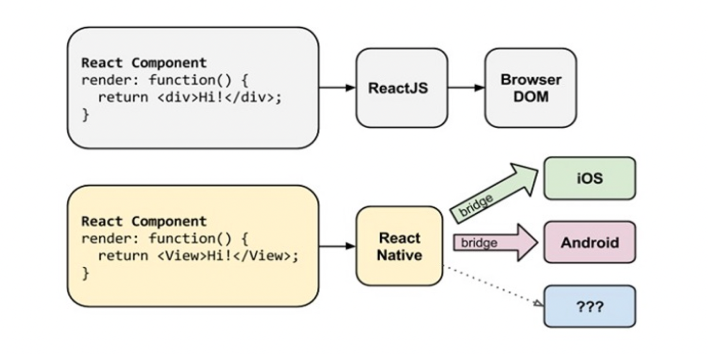

**Figure 3.1 Platform Specification**

**3.2 Firebase Database**

The Firebase Realtime Database is a database that is hosted in the cloud. Data is saved in JSON format and synced in real time across all connected clients. Data is synchronized in real time across all clients and is available even if your app is turned off. When you use our IOS, Android, and JavaScript SDKs to create cross-platform apps, all of your clients share a single Realtime Database instance and are immediately updated with the most recent data.

**How does it works ?**

By allowing secure access to the database directly from client-side code, the Firebase Realtime Database allows you to create rich, collaborative applications. Data is stored locally, and real-time events continue to trigger even when the user is offline, providing a responsive experience. When the device regains connectivity, the Realtime Database immediately merges any discrepancies between local data changes and remote updates that happened while the client was offline.

To specify how your data should be organized and when data may be read from or written to, the Realtime Database provides a powerful, expression-based rules language called Firebase Realtime Database Security Rules. Developers may determine who has access to what data and how they can access it when Firebase Authentication is used.

The Realtime Database is a NoSQL database, which means it differs from relational databases in terms of optimizations and functionality. Only actions that can be done rapidly are allowed in the Realtime Database API. This allows you to create a fantastic real-time experience that can serve millions of people while remaining responsive. As a result, it’s critical to consider how people will access your data and then arrange it properly.

We propose utilizing the Firebase JS SDK in the Expo Go app with the managed workflow if you want to leverage Firebase. On React Native, it enables Authentication, Firestore & Realtime databases, Storage, and Functions. Other modules, such as Analytics, are not supported by the Firebase JS SDK, however expo-firebase-analytics can be used instead. Because we cannot currently enable this in the Expo Go app, we recommend utilizing the basic workflow and react-native-firebase if you want access to the complete set of native firebase capabilities.

Fortunately, starting with version 3.1+, the Firebase JavaScript SDK offers virtually full support for React Native, so integrating it to our Expo app is a breeze. The user login components normally supplied by the Firebase SDKs will not function for React Native, therefore we’ll have to work around that, as we’ll see later in this article.(Anon, n.d.)

**Chapter 4. System Design and Specification**

The project’s most compatible technologies are listed below; these are more of the requirements that must be met for everything to work together in the project.

React-Native

Fire Base

**4.1 React-Native Development**

Homebrew is necessary to install React Native, which is subsequently followed by the installation of Node.js. The developer can use the command line to install React Native by utilizing the node package manager (npm), which is a complement to Node. Java JDK and Android SDK, as well as Android SDK Build-Tools23.0.1, must be installed on the computer to execute a React Native application on Android. With React Native installed, you can create a new React Native application and execute it by typing a new command. Figure shows the steps of the instructions.

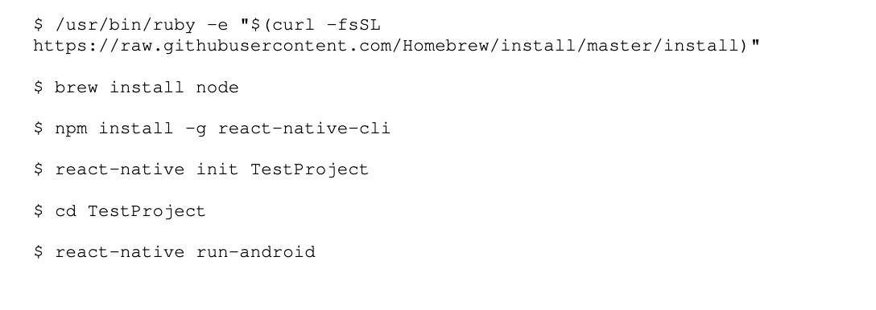

**Figure 4.1 How to get started with React-Native**

The following are the contents of the newly formed project Test Project:

* package.json – A file providing the project’s or project dependencies’ essential metadata.
* node modules/react-native/local-cli/cli.js – Contains the project’s dependencies and the CLI tool, node modules/react-native/cli.js. This script calls another helper script, node modules/react-native/init.sh, which puts the boilerplate code together.
* index.android.js – The project’s primary React Native file.
* android/ - This directory contains android-specific code that is used with index.android.js to create a React Native application.
* The iOS versions of the two previously mentioned files and folders are iOS/ and index.ios.js.(Anon, n.d.)

As previously said, index.android.js is the code’s primary file and provides fundamental functions from the start. First and foremost, the imports are listed. This declares that the application is React Native and specifies the required imports, such as components, stylesheets, and images. These imports may then be used to build components that can be shown in the app. More imports can be added to the import object if the developer demands them. (Anon, n.d.)

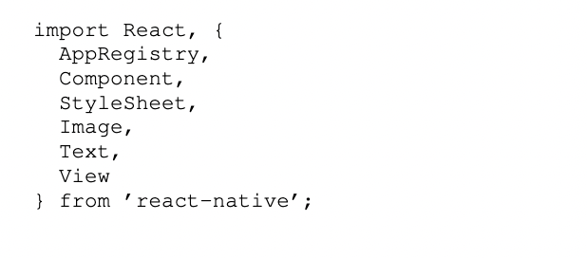

**Figure 4.2 Import in React-Native**

**4.2 Firebase SDK Setup**

We must first establish a Firebase account and a new project. We’ll be utilizing Firebase’s JavaScript SDK, so be sure to include it in your Expo project.

Expo install firebase.

Firebase Console gives you an API key and other identifiers for your project that you’ll need to get started. Each field’s meaning and location in your console are described in depth by firebase-web-start.

Firebase Realtime Database (RTDB) comes with a security rule that requires all devices viewing your data to be authorized. We haven’t built up any authentication yet, so we can turn it off for the time being until we finish out the remainder of our project.

Under the Rules tab of Firebase Console >> Realtime Database, you should notice a default set of rules already supplied for you. The regulations should be changed to:(Anon, n.d.)

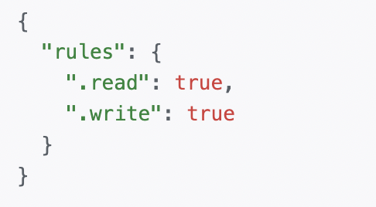

**Figure 4.3 Firebase Rules in React-Native**

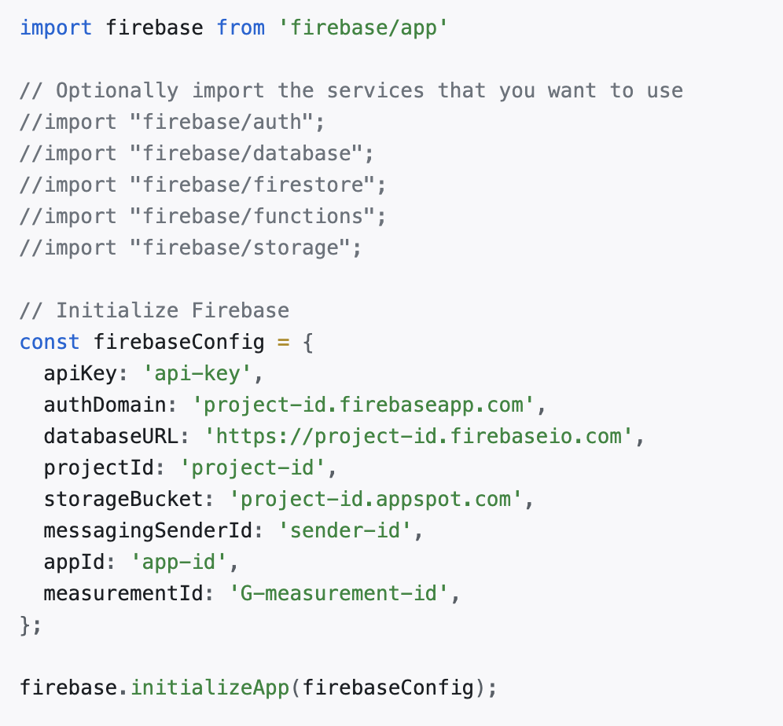

**Figure 4.4 How to Connect Firebase with React-Native**

**4.3 System Model**

In Software Engineering, I’m designing our project using the “Prototyping Model.”

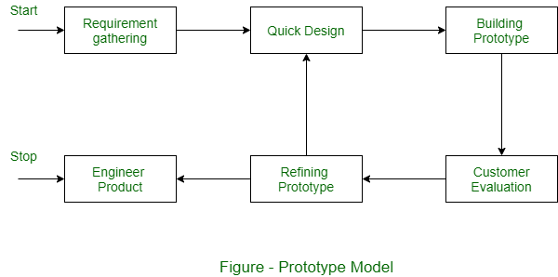

**Figure 4.4 System Model**

Prototyping is a Software Development Model in which a prototype is constructed, tested, and revised as needed until an acceptable prototype is achieved from which the entire system or product may be developed.

The steps in the prototyping model are as follows:

1. As many specifics as feasible are defined for the new system requirements.
2. A rough design for the new system is produced.
3. A preliminary design is used to create a first prototype of the new system.
4. The users critically assess the initial prototype, highlighting its merits and weaknesses, as well as what should be added and deleted.
5. The initial prototype is tweaked in response to feedback from consumers.
6. The second prototype is assessed in the same way as the first prototype was.
7. Iterate the preceding stages as needed until the consumers are happy that the prototype accurately depicts the desired final product.
8. Based on the result, the final system is built.
9. The system has been carefully tested and assessed.

**4.4 System Architecture**

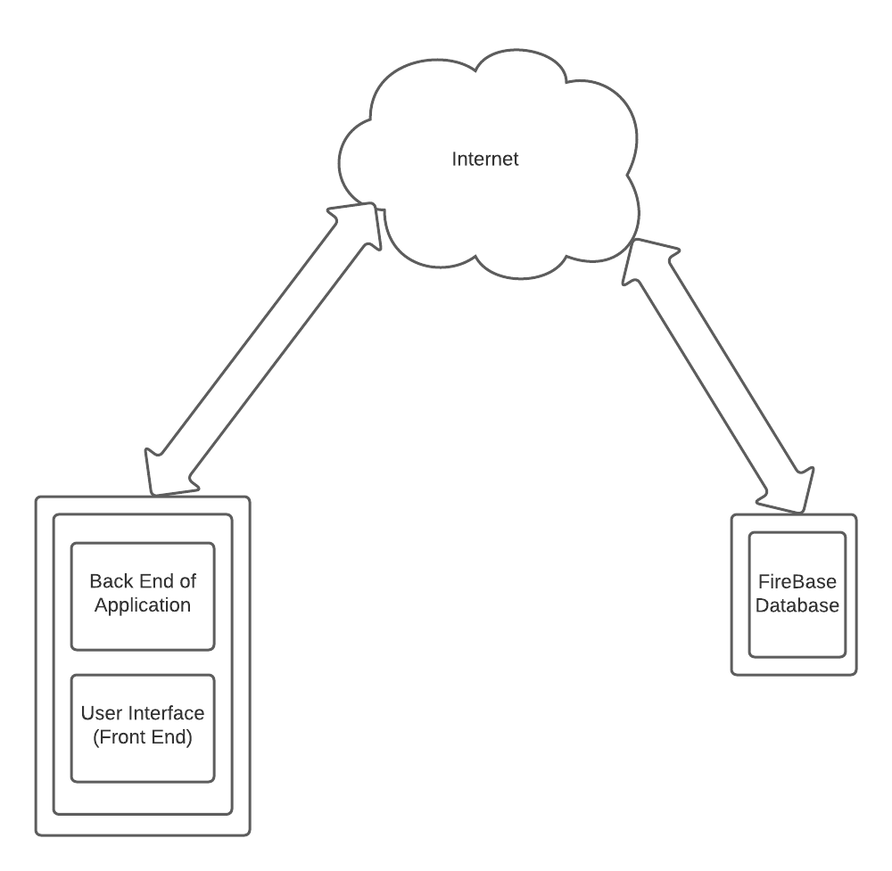

**Figure 4.5 System Architecture**

The patient or the doctor adds his/her data with the help of User Interface which is then processed by the Back End of Application and later with the use of internet the data is stored into the firebase database. Now, the data which is stored in the firebase can be viewed by the patient or doctor with the help of internet into their own application ‘s User Interface.

**Chapter 5. Implementation**

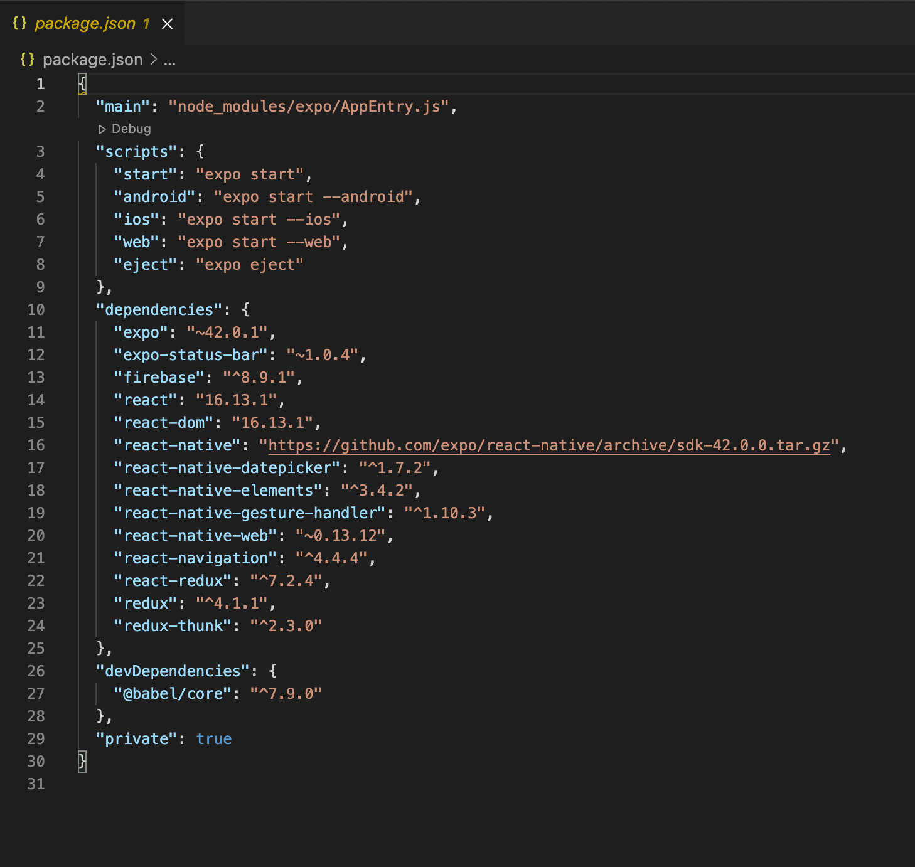

**Figure 5.1 required package used**

As seen in the above screenshot, firebase is utilized in this project with the aid of react-native, and several essential packages have been installed. Expo is a term that refers to the dependencies and packages that will be widely used in the DBT. The use of React-native packages greatly improves the project's quality and efficiency.

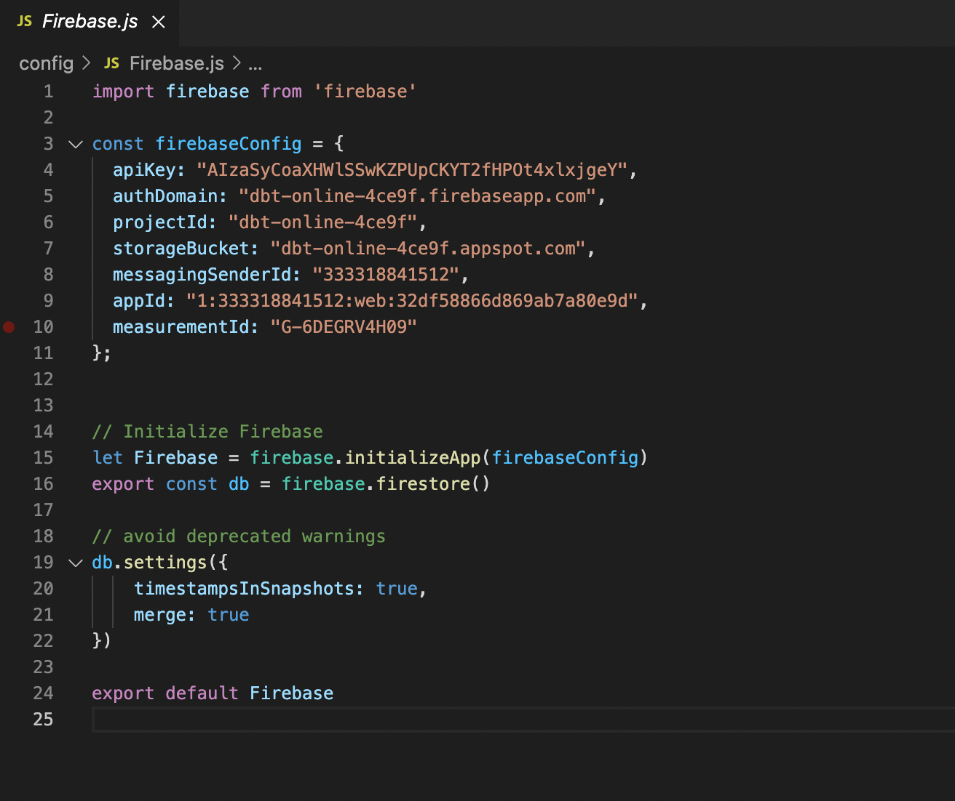

**Figure 5.2 Firebase Authentication**

Above screenshot provides required firebase authentication for react-native application to store data from API to firebase database.

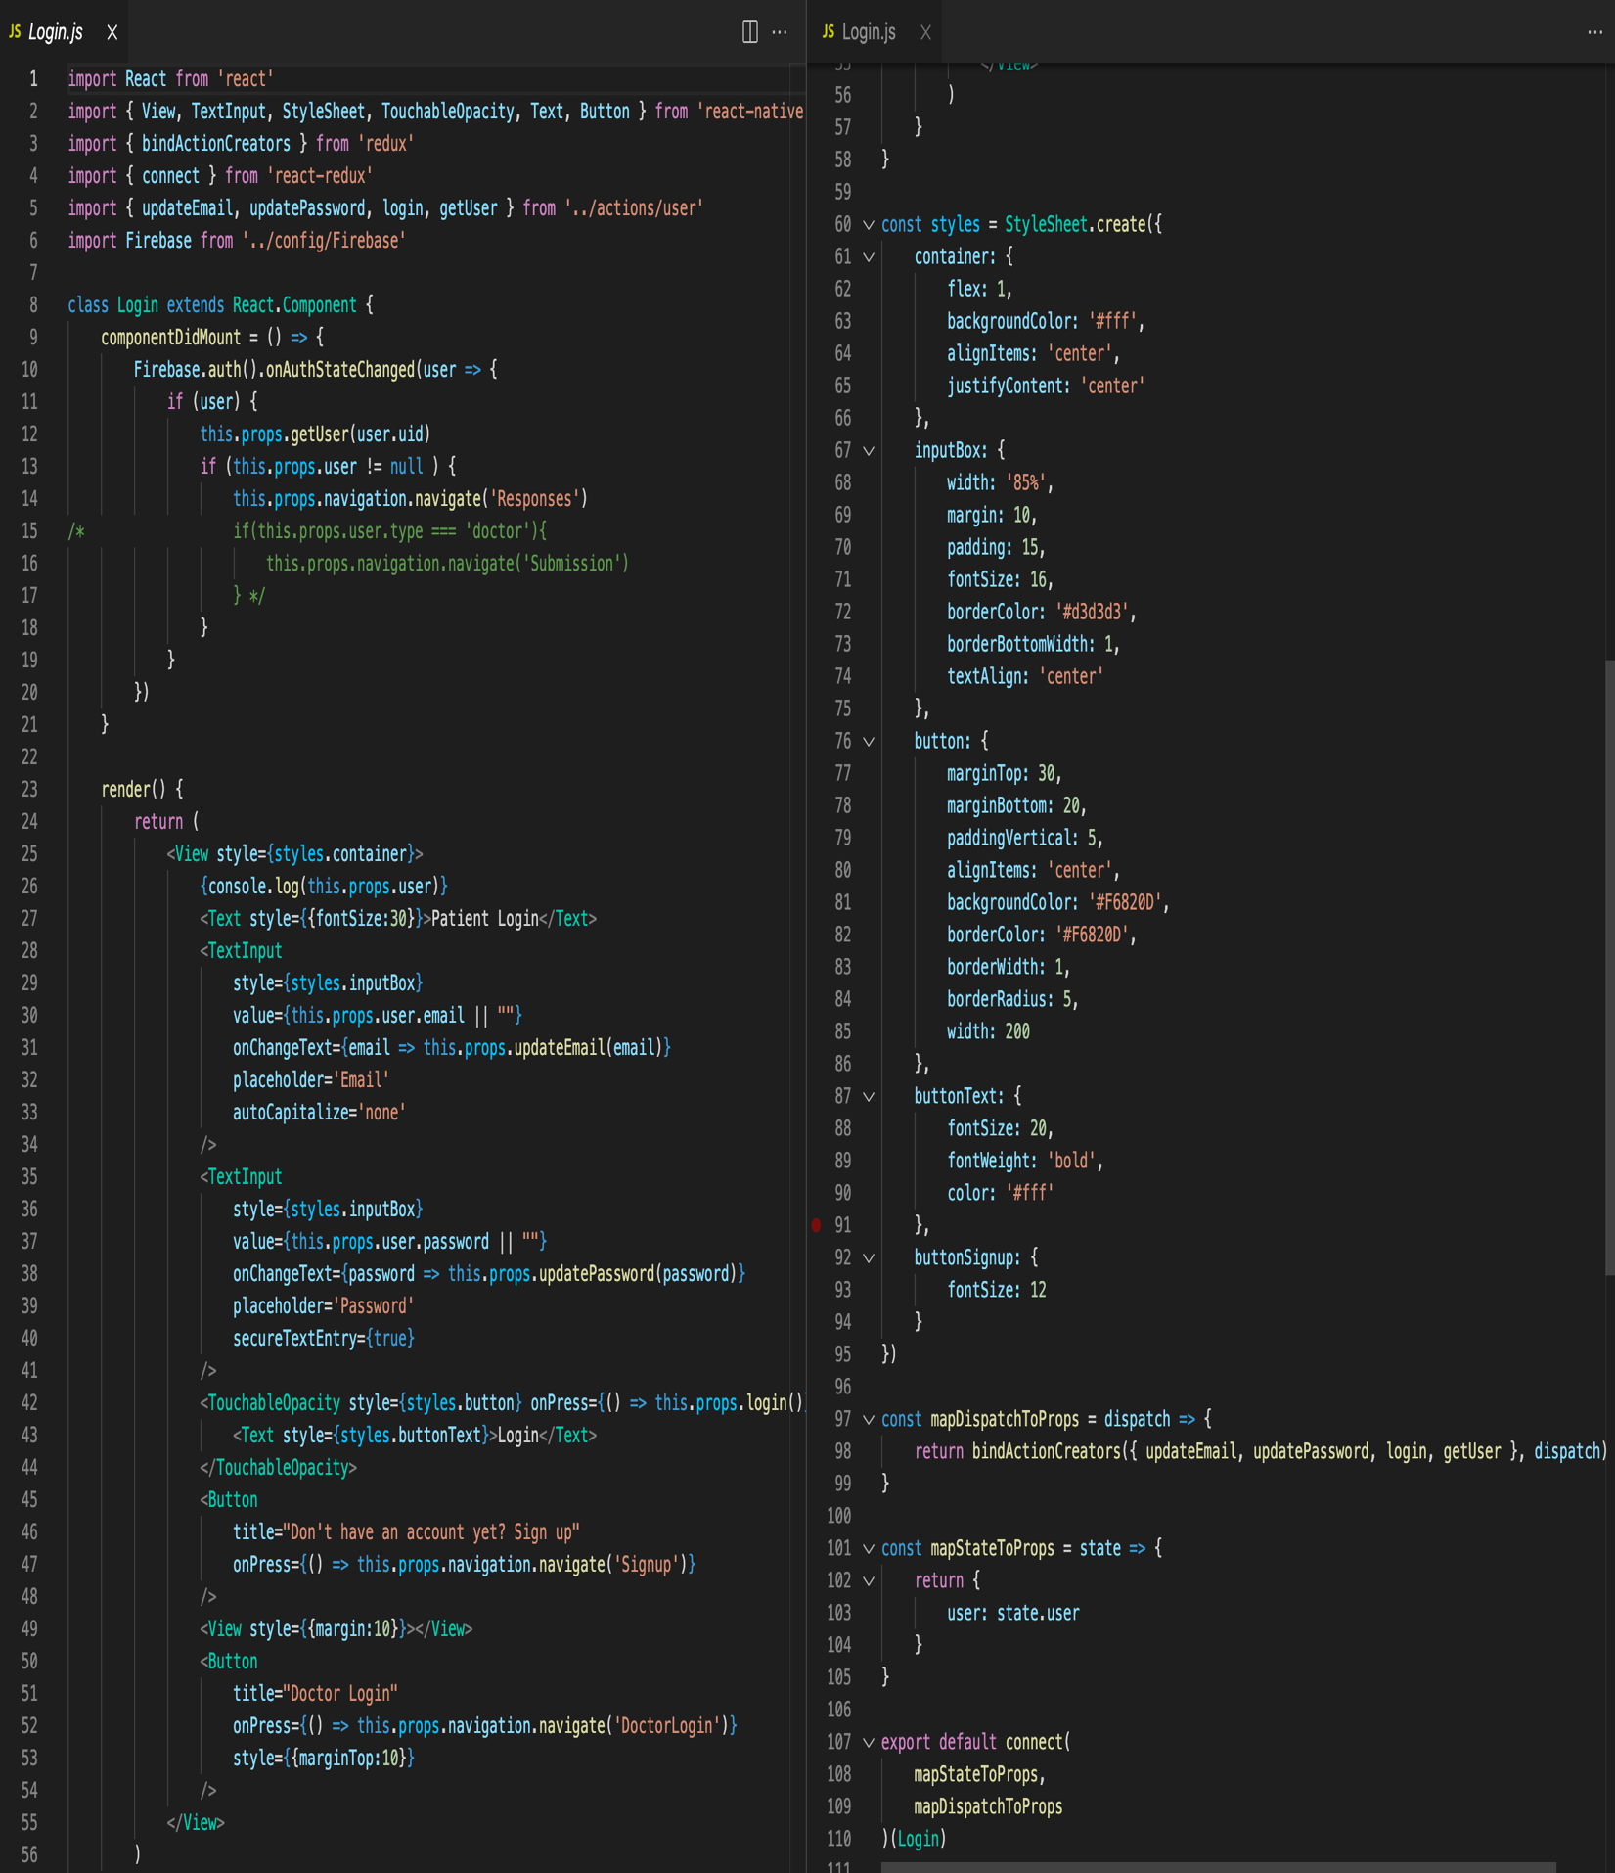

**Figure 5.3 Patient Login/SignIn Page**

This page displays the code for logging in and signing in patients. If the patients are new, he can make an account by clicking the sigIn button. If the patient is older, he can log in using the information entered before.

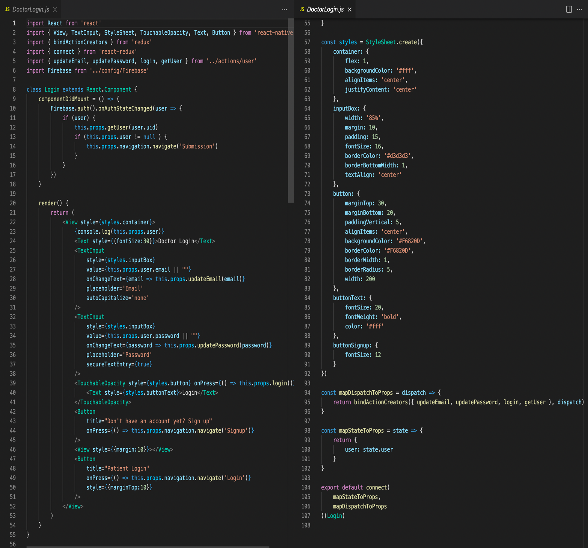

**Figure 5.4 Doctor Login/SignIn Page**

This page shows the code for signing in and signIn into specialist. On the off chance that the patients are new, they can make a record by tapping the signIn button. On the off chance that the patient is more established, he can sign in utilizing the data entered previously.

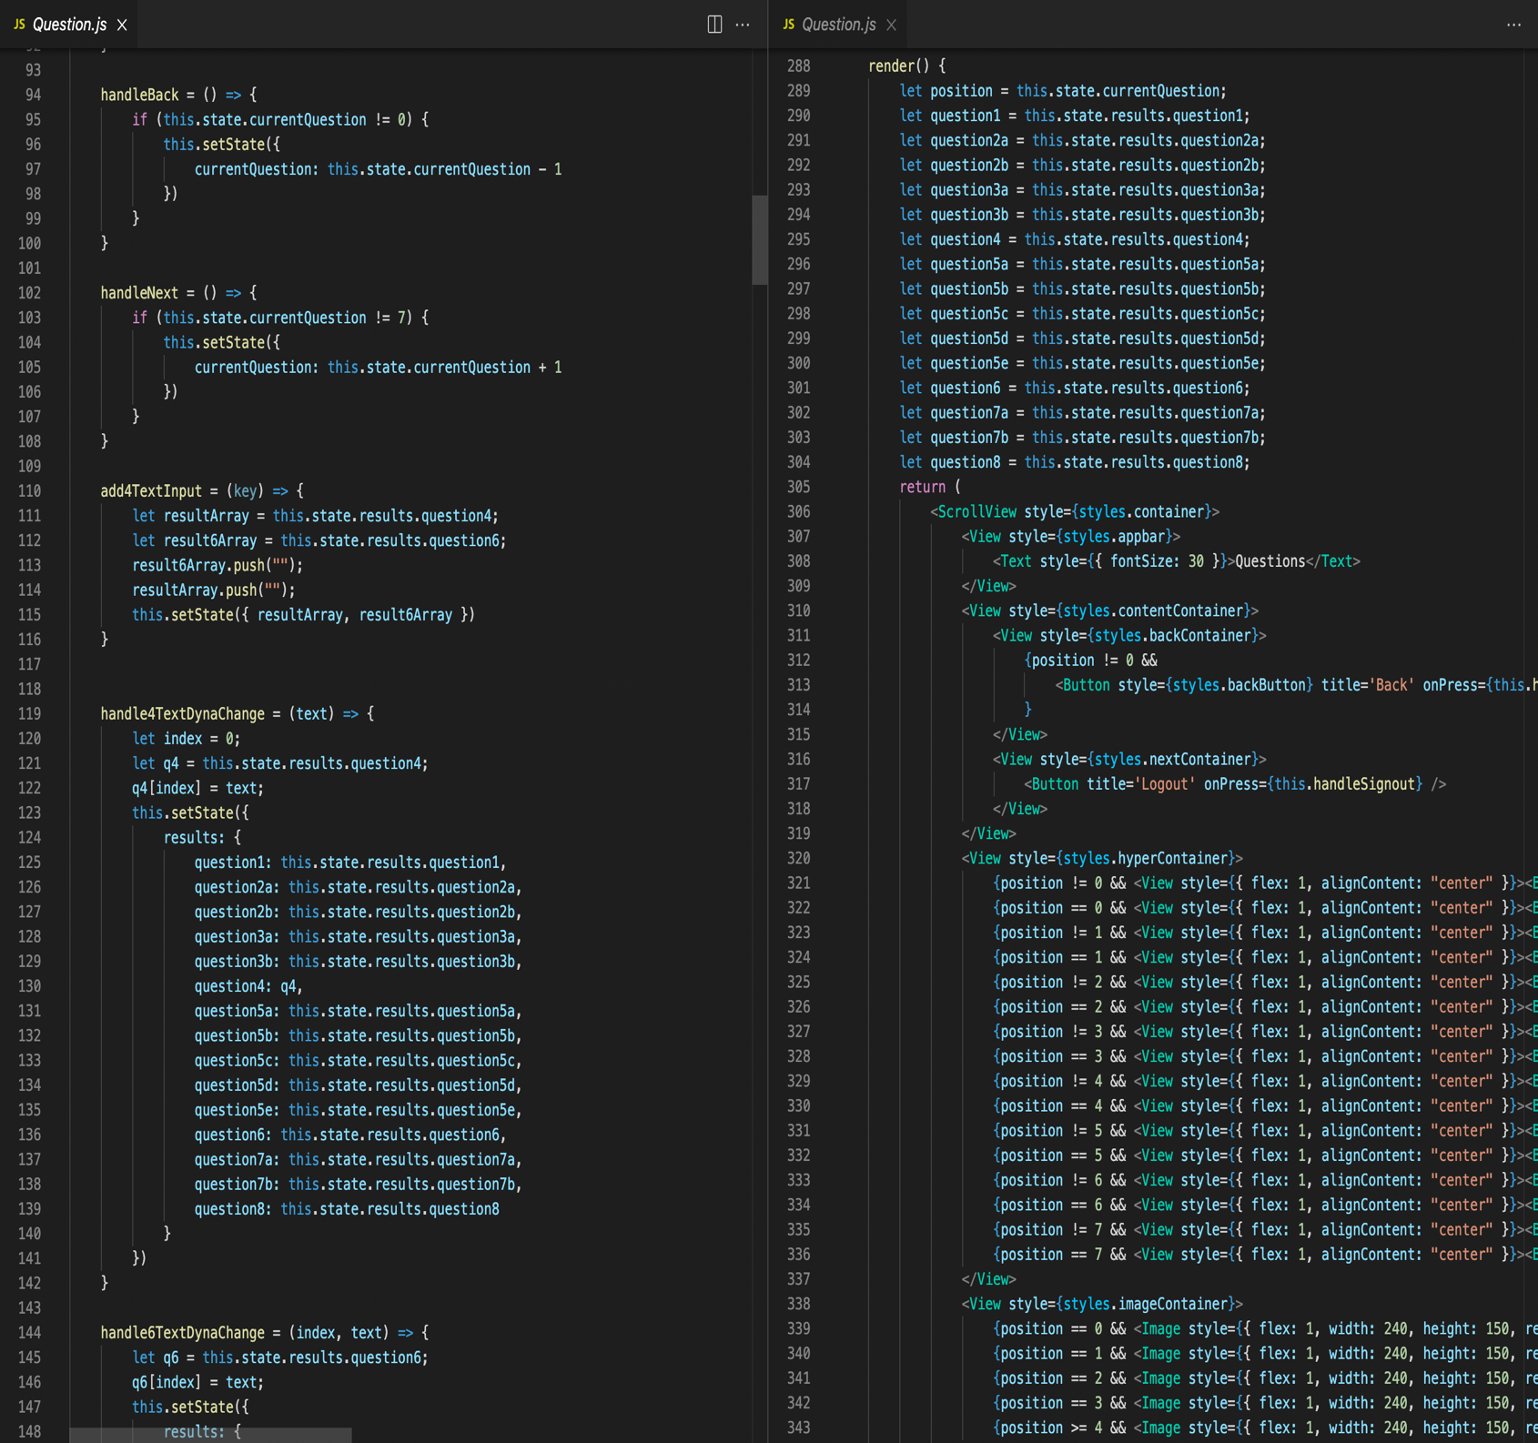

**Figure 5.5 Questions Page**

The above-mentioned code depicts the coding for a query section. The patients are given a platform to type their questions regarding an appointment or any particular health condition etc and these questions will be displayed to the doctor so that they can give necessary solutions.

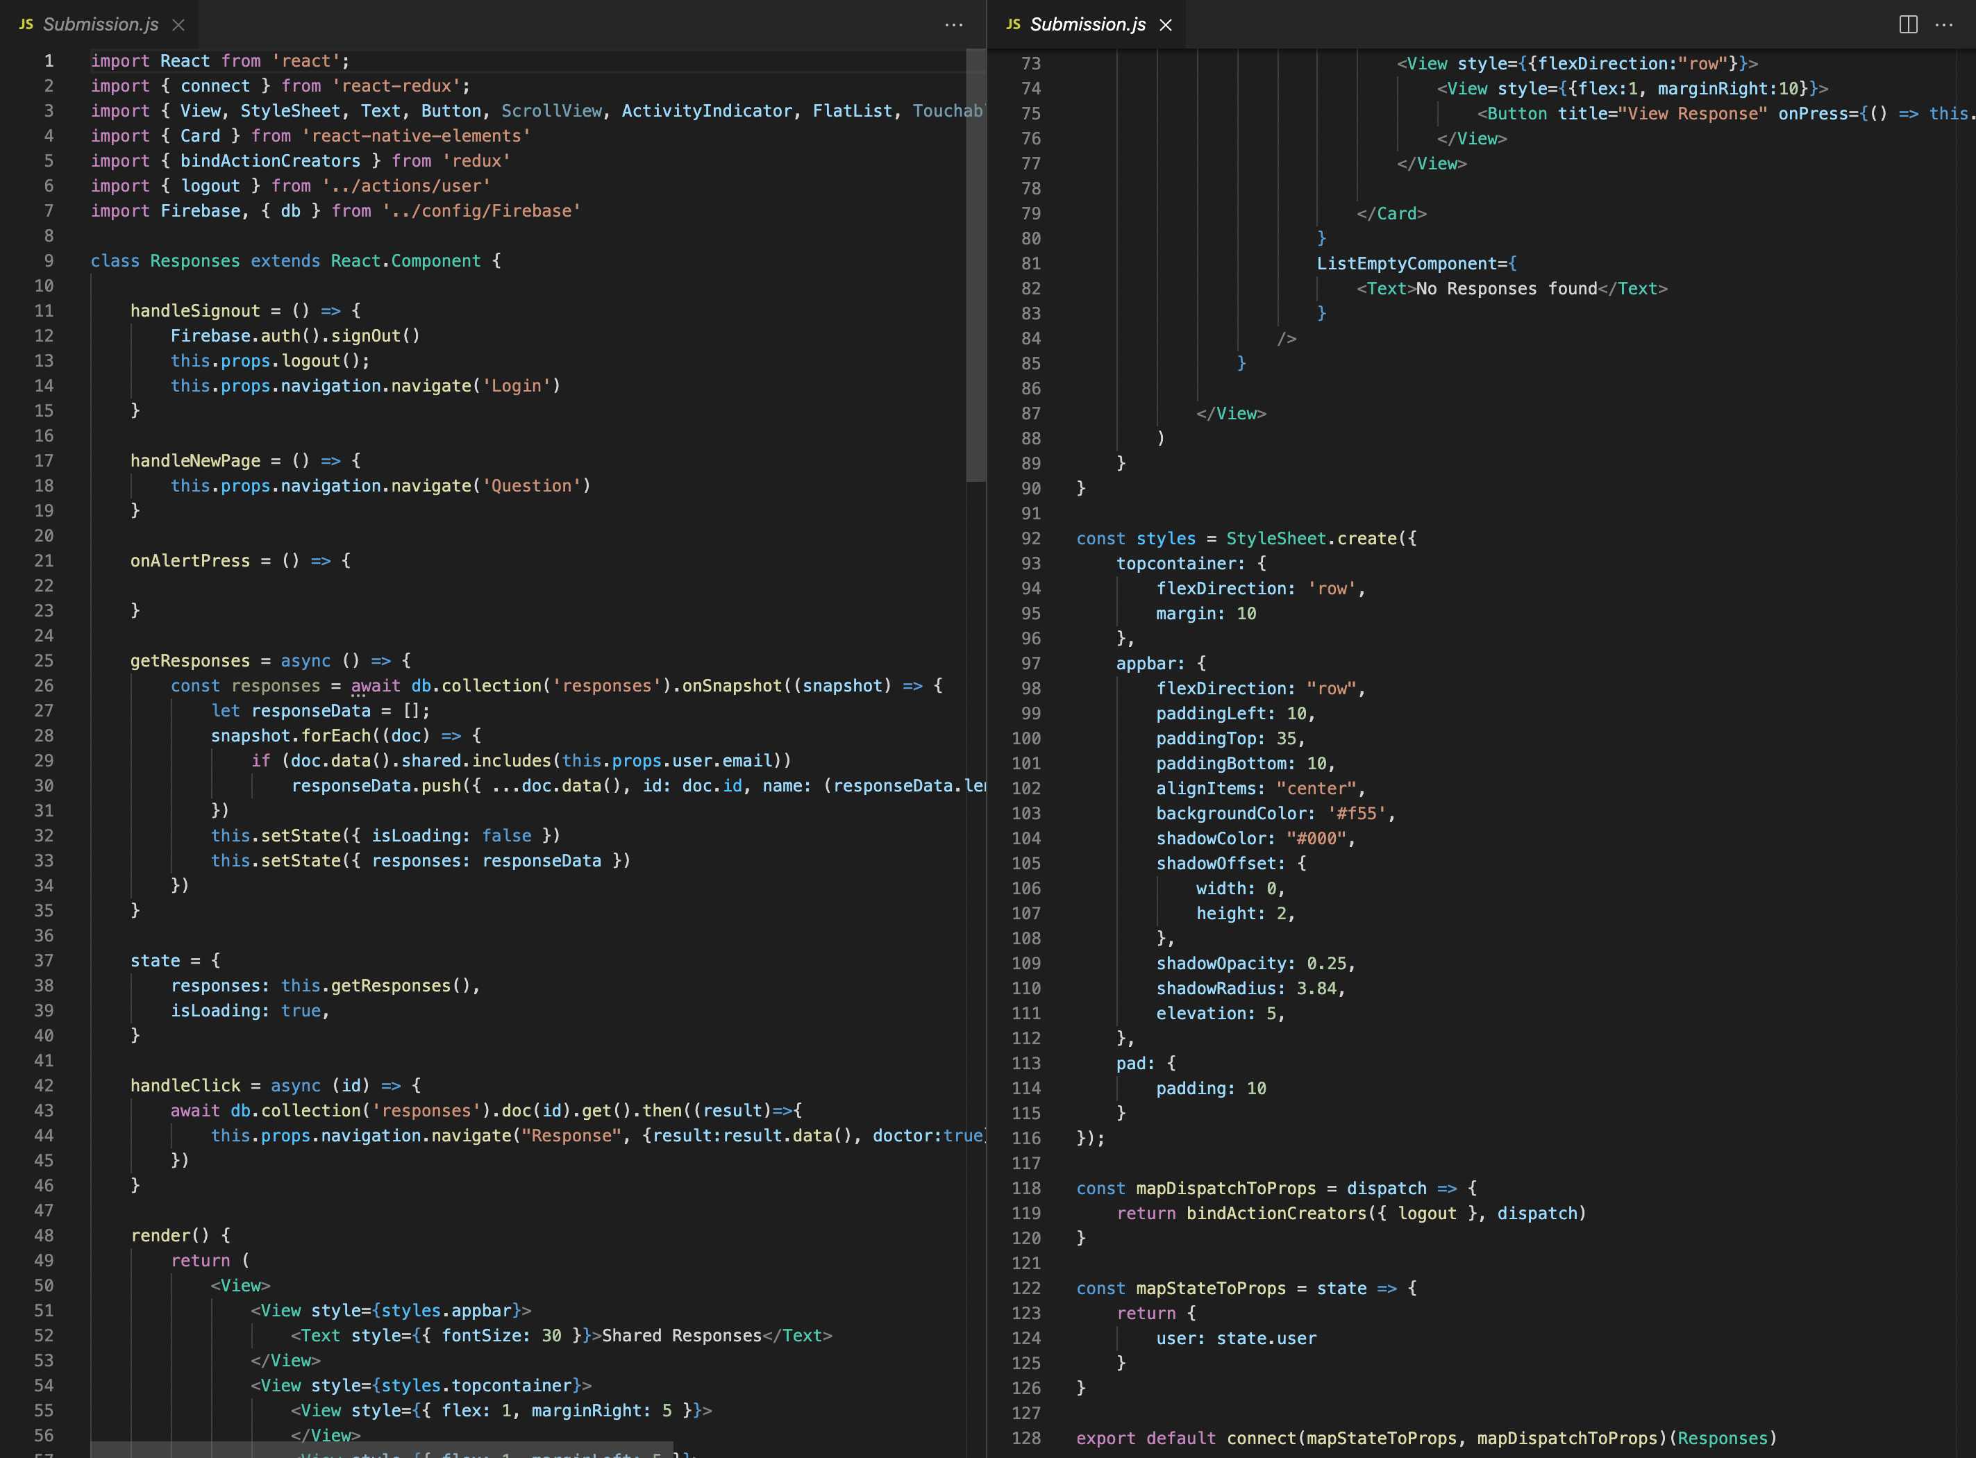

**Figure 5.6 Submit of Questions Page**

The above-mentioned code illustrates the coding for analysing a patient's history using questions that the patient must respond. Patients are provided a platform to write their responses about their health status, any specific difficulties, and the answers are saved in the database once they hit the submit button.

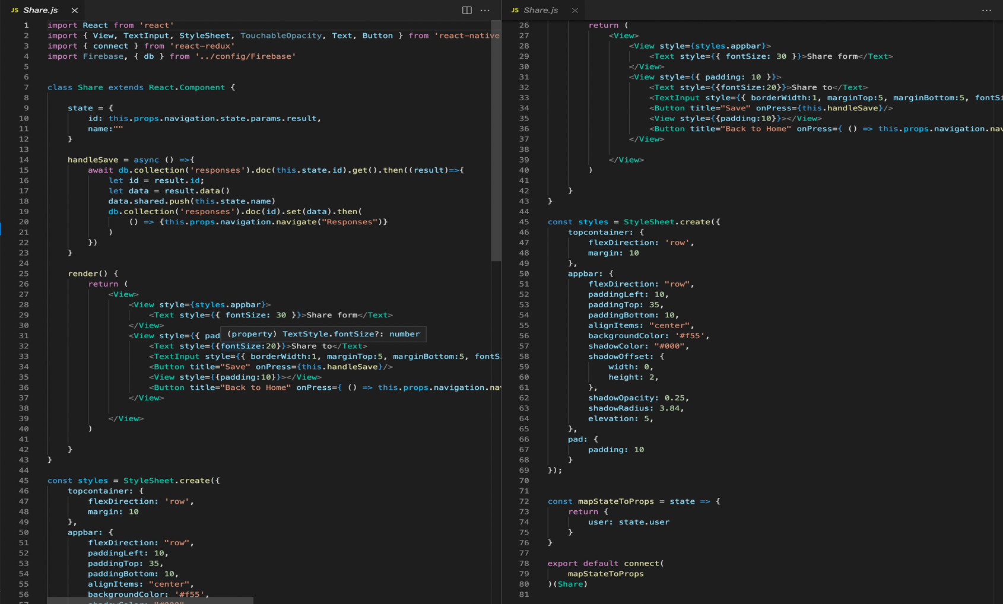

**Figure 5.7 Questions Sharing Page**

Here the code illustrates that the answers of the patient stored in the database can be shared by the patient to the doctor and can be saved by the doctor for future reference.

**Chapter 6. Testing and Evolution**

|  |  |
| --- | --- |
|  |  |

**Figure 6.1 Testing-1**

The photo represents the log in button for patient as well as doctor for starting the application, this feature is for the individuals already having an account. Whereas, for new users a signup button is available.

|  |  |
| --- | --- |
|  |  |

**Figure 6.2 Testing-2**

The left corner in the picture depicts a patients logged in page which consists of their form. Here, there are three features available for the patient.

1) The patient can share their form through the share button.

2) The patient can view their response through the view response button.

3) The delete button helps in deleting the data of patient.

The picture on the right illustrates doctors logged in page where doctors can view the responses sent by the patients

|  |  |
| --- | --- |
|  |  |
|  |  |

**Figure 6.3 Testing-3**

This picture explains that when a patient logs in and clicks on new form then set of questions are displayed. There are 4 questions displayed per page. The patient can type their answer in the answer bar. The next button is used to take the cursor to the next question. The back button is used to go backwards to the previous question and back to home button is used to return to the main screen. The logout button is used to logout of the session. In some questions a special tab is available for mentioning the dates on which there was a change in their health condition.

|  |  |
| --- | --- |
|  |  |
|  |  |

**Figure 6.4 Testing-4**

When a patient signs in and selects "new form," a series of questions appears. On each page, there are four questions. In the answer bar, the patient can input their response. The pointer is moved to the next question by pressing the next button. The back button returns you to the previous question, and the back to home button returns you to the main screen. To log out of a session, press the logout button. A separate tab is offered in some queries for indicating the dates on which their health status changed.

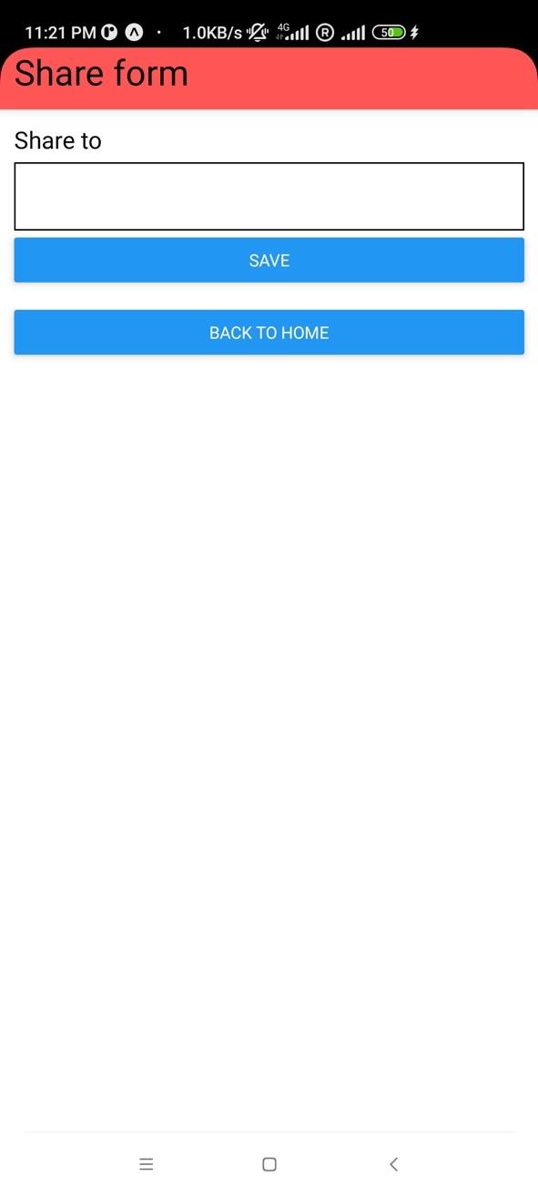

**Figure 6.5 Testing-5**

The patient can share their answered form through this share form. The patient needs to share this to the doctor by typing the email address. The save button is used to save this response and the back to home button takes the person to the main page.

|  |  |
| --- | --- |
|  |  |

**Figure 6.6 Testing-6**

The photo shows the doctors application screen where he/she can type comment in the comments till now section that is give advice on the questions answered by the patient. The next button is used to go to the next page. The back button is used to go to the home page. The submit comment button submits the comments typed by the doctor.

**Chapter 7. Conclusion and Future Work**

This project work clarifies the motivation for conducting this research from beginning of the work. Also, the learning and execution assignment of the model was also thoroughly explained. Using the react-native and the firebase database has helped in accomplishment of a better precision for the application. Considering, the situation of the on-going COVID-19 pandemic a need for maintaining social distancing and spread of infection without compromising mental health, this application proves to be a boon in current situation for the patients as well as the doctors. This application proves its worth in the current scenario. The application will contribute enormously to the general medical care framework by providing an online examination platform for the doctors and a relief platform for the patients.

**Future Work**

The Future of this health application would take a huge turn with huge improvement overall because of the huge potential it has. The model can be used in so many functioning areas for example in providing treatment at home to everyone who won't be able to move out of their houses whether it be due to any disability or because of a pandemic. The barrier of physical presentation at a clinic will be removed by the usage of this model. The other major improvements would be improving the model itself with features like adding a chatbot system so that the patient can personally keep in touch with the doctors and solve their queries, this chatbot system will also help an individual during emergency conditions. Further, a feature of video conferencing can also be added which can help the doctor to understand the patient's current situation and health more thoroughly. Future work could also include an in-built calendar in the application which would provide a reminder or alarm for the doctor or the patient regarding booking of their appointment or regarding consumption of any prescribed medication.

**References**

1. Ben-Porath, D. *et al.* (2020) ‘Dialectical Behavioral Therapy: An Update and Review of the Existing Treatment Models Adapted for Adults with Eating Disorders’. *Eating Disorders*, 28(2), pp. 101–121. DOI: 10.1080/10640266.2020.1723371.
2. Blackford, J.U. and Love, R. (2011) ‘Dialectical Behavior Therapy Group Skills Training in a Community Mental Health Setting: A Pilot Study’. *International Journal of Group Psychotherapy*, 61(4), pp. 645–657. DOI: 10.1521/ijgp.2011.61.4.645.
3. Dimeff, L. and Linehan, M.M. (2001) ‘Dialectical Behavior Therapy in a Nutshell’. p. 3.
4. *FULLTEXT02.Pdf*.
5. *General-Handout.Pdf*.
6. Jiménez, S.E. *et al.* (2021) *Machine Learning Detects Predictors of Clinical Change after Dialectical Behavior Therapy in Borderline Personality Disorder*. PsyArXiv DOI: 10.31234/osf.io/pm5rz.
7. Kumari, R. ‘An Overall Understanding of Dialectical Behavior Therapy to Control the Symptoms of Borderline Personality Disorder – A Research Review’. p. 9.
8. Linehan, M.M. and Wilks, C.R. (2015) ‘The Course and Evolution of Dialectical Behavior Therapy’. *American Journal of Psychotherapy*, 69(2), pp. 97–110. DOI: 10.1176/appi.psychotherapy.2015.69.2.97.
9. Sahranavard, S. and Miri, M.R. (2018) ‘A Comparative Study of the Effectiveness of Group-Based Cognitive Behavioral Therapy and Dialectical Behavioral Therapy in Reducing Depressive Symptoms in Iranian Women Substance Abusers’. *Psicologia: Reflexão e Crítica*, 31(1), p. 15. DOI: 10.1186/s41155-018-0094-z.
10. Salamin, V. *et al.* (2021) ‘Adaptations de la thérapie comportementale dialectique ambulatoire en période de pandémie COVID-19 et conséquences du confinement sur des patients souffrant d’un état-limite’. *Annales Médico-psychologiques, revue psychiatrique*, 179(2), pp. 131–136. DOI: 10.1016/j.amp.2020.08.006.
11. Schroeder, J. *et al.* (2018) ‘Pocket Skills: A Conversational Mobile Web App To Support Dialectical Behavioral Therapy’. In *Proceedings of the 2018 CHI Conference on Human Factors in Computing Systems*. CHI ’18: CHI Conference on Human Factors in Computing Systems. Montreal QC Canada: ACM, pp. 1–15. DOI: 10.1145/3173574.3173972.
12. *The Pros and Cons of Using React Native*. (2018) *MindInventory*. Available at: https://www.mindinventory.com/blog/pros-cons-using-react-native/ (Accessed: 1 September 2021).
13. *Using Firebase*. *Expo Documentation*. Available at: https://docs.expo.dev/guides/using-firebase (Accessed: 2 September 2021c).
14. *What Is Software? - Definition from Techopedia*. *Techopedia.com*. Available at: http://www.techopedia.com/definition/4356/software (Accessed: 1 September 2021d).
15. Wilks, C. *et al.* (2017) ‘Internet-Delivered Dialectical Behavioral Therapy Skills Training for Suicidal and Heavy Episodic Drinkers: Protocol and Preliminary Results of a Randomized Controlled Trial’. *JMIR Research Protocols*, 6(10), p. e207. DOI: 10.2196/resprot.7767.